**Speed Control of Induction Motors**

We have discussed about the starting and braking of induction motors but what about controlling the speed during the running time. **Speed control of induction motors** can be done in six methods which are

1. Pole changing
2. Stator voltage control
3. Supply frequency control
4. Eddy current coupling
5. Rotor resistance control
6. Slip power recovery

We know that the speed of the induction motor is inversely proportional to number of poles. So it is possible to increase or decrease the speed of the induction motor if the number of the poles are decreased or increased respectively. The motor in which the provision of changing the number of poles is present, they are called ‘pole changing motor’ or ‘multi speed motor’. Another method of controlling the speed of induction motor drives is the stator voltage control. Stator voltage is directly responsible for the rotating speed of the rotor. Torque is proportional to voltage squared and the current is proportional to the voltage. So, if the stator voltage is reduced the speed reduces and similarly if the stator voltage is increased the speed also increases. 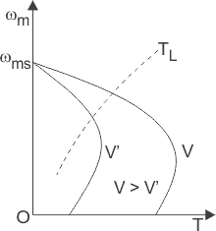The speed of an induction motor is proportional to the product of the supply frequency and air gap flux. But as there is a chance of [magnetic saturation](https://www.electrical4u.com/magnetic-saturation/) while decreasing the supply frequency, that’s why not only the frequency but the v/f (i. e the ratio of supply voltage and frequency) is controlled and this ratio is tried to be kept constant. And if the speed is needed to be changed the ratio of v/f is changed accordingly. 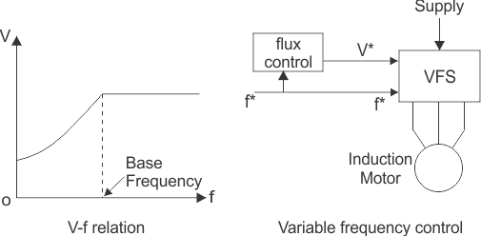The [eddy current](https://www.electrical4u.com/hysteresis-eddy-current-iron-or-core-losses-and-copper-loss-in-transformer/) speed control method is done by placing an eddy current clutch between an induction motor is running at a fixed speed and the variable speed load. Now what is this eddy current clutch? It is nothing but an induction motor drives in which both stator and the rotor are allowed to rotate. The rotor is coupled with the main induction motor. When eddy currents are produced in the rotor drum, their interaction with the stator field and a torque is produced which rotates the main motor. By controlling the DC current through the stator winding the speed of the motor can be controlled. Depending on the rotor resistance, the speed of the rotor falls or increases. The variation of speed torque characteristics with respect to change in rotor resistance is shown in the figures below. This speed controlling method is better than many other methods because of low cost. 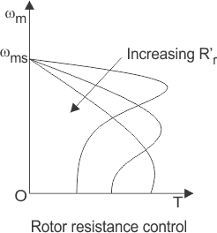

# VSI Fed Induction Motor Drives

**Definition:** The voltage source inverter is defined as the inverter which takes a variable frequency from a DC supply. The input voltage of the voltage source inverter remains constant, and their output voltage is independent of the load.The magnitude of the load current depends on the nature of the load impedance.

The figure below shows a voltage source inverter employing transistor.

[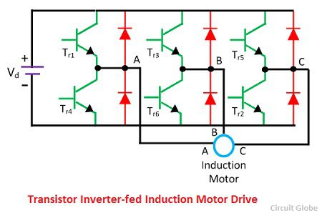](https://circuitglobe.com/wp-content/uploads/2016/11/transistor-inverter-fed-niduction-motor-drive.jpg)

The voltage source inverter use self-commutated device like MOSFET, IGBT, GTO, etc. It is operated as a stepped-wave inverter or a pulse width modulation. When the voltage source inverter is operated as a stepped-wave inverter, then the transistor is switched in the sequence of their number with a time difference of T/6.

The each of the transistors is kept on for the duration of T/2, where T is the period for one cycle. The waveform of the line voltage is shown in the figure below. The frequency of the inverter is varied by varying T, and the output voltage of the inverter is varied by varying DC input voltage.

[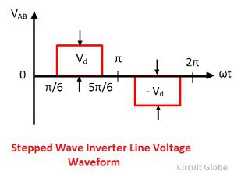](https://circuitglobe.com/wp-content/uploads/2016/11/stepped-wave-inverter-line-voltage-waveform.jpg)

[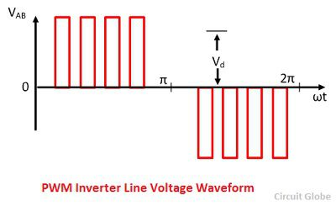](https://circuitglobe.com/wp-content/uploads/2016/11/pwm-inverter-line-votlage-waveform.jpg)

When the supply is DC, then the variable DC input is obtained by connecting a chopper between DC supply and inverter.

[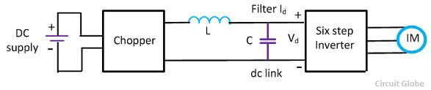](https://circuitglobe.com/wp-content/uploads/2016/11/vsi-conrolled-inductionmotor-drive-1.jpg)

When the supply is AC, then the DC input voltage is obtained by connecting the controlled rectifier between the AC supply and inverter shown in the figure below.The capacitor C filter out the harmonics in DC link voltage.

[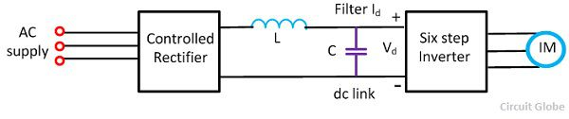](https://circuitglobe.com/wp-content/uploads/2016/11/voltage-source-inverter-controlled-induction-motor-drive.jpg)

The main drawback of the VSI induction motor drive is the large harmonics of the low frequency in the output voltage. The harmonics increases the loss in the motor and cause the jerky motion of the rotor at low speed.

CSI (Current Source Inverter)

CSI is used in many applications due to its flexibility, reliability and commutation. CSI operates on closed loop and capable of generation, by using CSI variable frequency is obtained.

[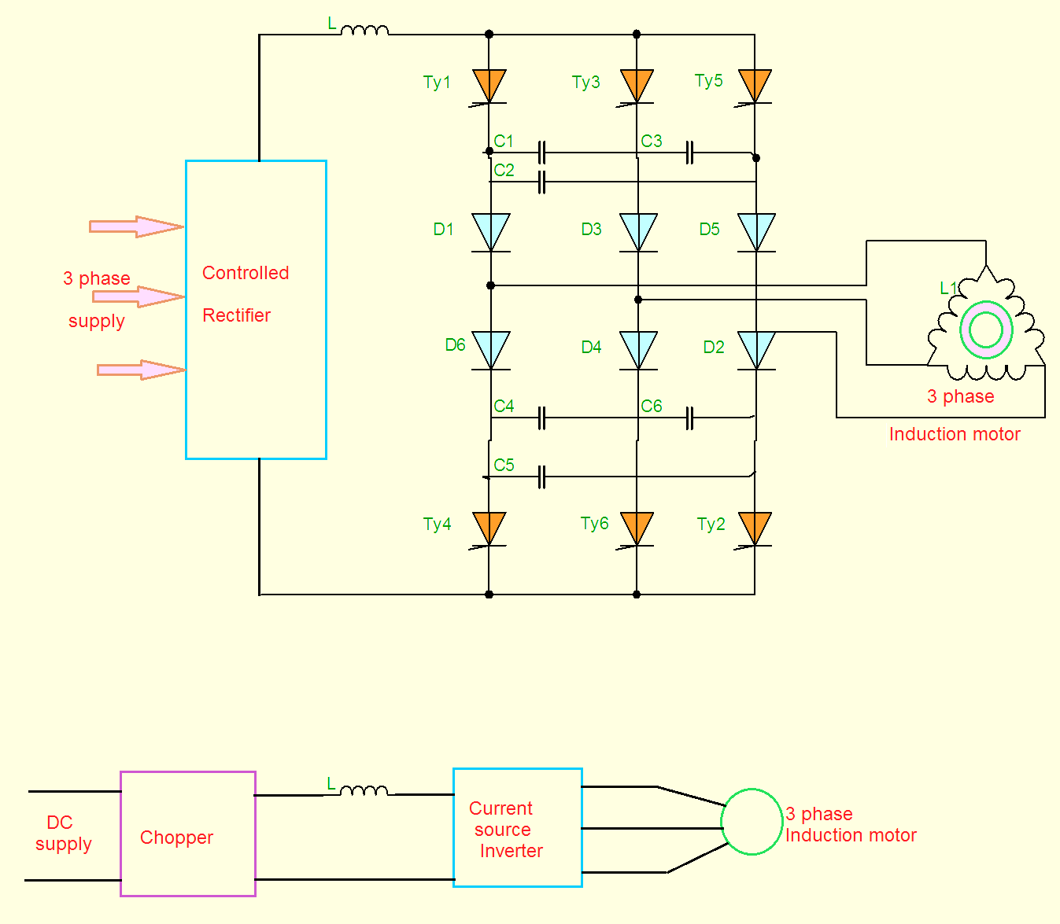](https://3.bp.blogspot.com/-DtUizD3ThX8/Vxdog3t1RiI/AAAAAAAADoA/_HE_CP8mqhIZFVEu1pEYjZ2ZGRqQOC4TQCLcB/s1600/CSI.png)

The variable  frequency control  of an induction motor can also  be obtained using CSI. The inductor is connected in series with the input.

* By varying the thyristors conduction periods and Inverter, the DC current is converted into a three phase current source.

* The stator current is a function of rotor frequency, by keeping flux constant the magnitude of stator is controlled by the rotor frequency.

* When supply is AC the controlled rectifier converts it into variable DC, if the supply is DC  the chopper manages the circuit.

* From the circuit diagram for commutation of  six thyristors the circuit is provided with six diodes and six capacitors.

* The six thyristors are triggered with a phase difference of 180°. The diodes are used for preventing discharge of capacitors through load.

Characteristics:

*For below rated speed, motor operates at constant flux mode.

*For above rated speed, motor operates at field weakening mode.

*For speed equal to rated speed, the voltage reach its rated value and no further increase of speed.

The characteristics are shown below on taking percentage slip on x-axis and percentage torque on y-axis.

[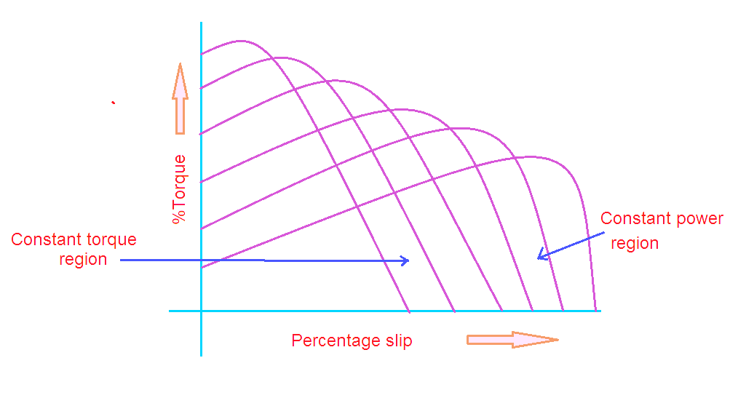](https://3.bp.blogspot.com/-tDMDwBZxlhQ/VxdonccfXfI/AAAAAAAADoE/LuWkGVgRJIIC7KqG5qLiMCxxScQBDGM8ACLcB/s1600/CSI+characteristics.png)

Advantages:

1. CSI is robust and simple

2. Four quadrant operation is possible

3. Controlling the speed in simple way

4. Better controlled performance.

Disadvantages:

1. Cost is expensive with PWM technique

2. Unsupported for multi-motor operation

3. CSI not used in open loop control drives

4. Undesirable dynamic performance

5. At no-load condition it is difficult to operate.

Comparison of VSI and CSi

|  |  |
| --- | --- |
| **VSI** | **CSI** |
| VSI is fed from a DC voltage source having small or negligible impedance. | CSI is fed with adjustable current from a DC voltage source of high impedance. |
| Input voltage is maintained constant | The input current is constant but adjustable. |
| Output voltage does not dependent on the load | The amplitude of output current is independent of the load. |
| The waveform of the load current as well as its magnitude depends upon the nature of load impedance. | The magnitude of output voltage and its waveform depends upon the nature of the load impedance. |
| VSI requires feedback diodes | The CSI does not require any feedback diodes. |
| The commutation circuit is complicated | Commutation circuit is simple as it contains only capacitors. |
| Power BJT, Power MOSFET, IGBT, GTO with self commutation can be used in the circuit. | They cannot be used as these devices have to withstand reverse voltage. |

## Closed-Loop Speed Control

The block diagram of the closed loop speed control system is shown in the figure below. This system used an inner control loop within an outer speed loop. The inner control loop controls the motor current and motor torque below a safe limit.

[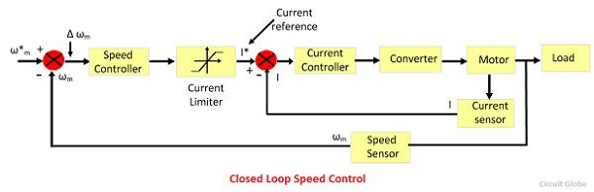](https://circuitglobe.com/wp-content/uploads/2016/10/closed-loop-speed-control.jpg)Consider a reference speed ω*m which produces a positive error Δ ω*m. The speed error is operated through a speed controller and applied to a current limiter which is overloaded even for a small speed error. The current limiter set current for the inner current control loop. Then, the drive accelerates, and when the speed of the drive is equal to the desired speed, then the motor torque is equal to the load torque. This, decrease the reference speed and produces a negative speed error.

When the current limiter saturates, then the drive becomes de-accelerate in a braking mode. When the current limiter becomes desaturated, then the drive is transferred from braking to motoring.